**Railway Ticket Booking**

**Objective :-**

This project implements a chatbot using **LangChain** and **Hugging face** that can:

* Answer general chat queries.
* Fetch real-time **train status** using a Railway API.
* Maintain **conversational memory** for better interactions.
* Dynamically decide whether to **respond normally** or **use tools** for fetching train details.

**Design :-**

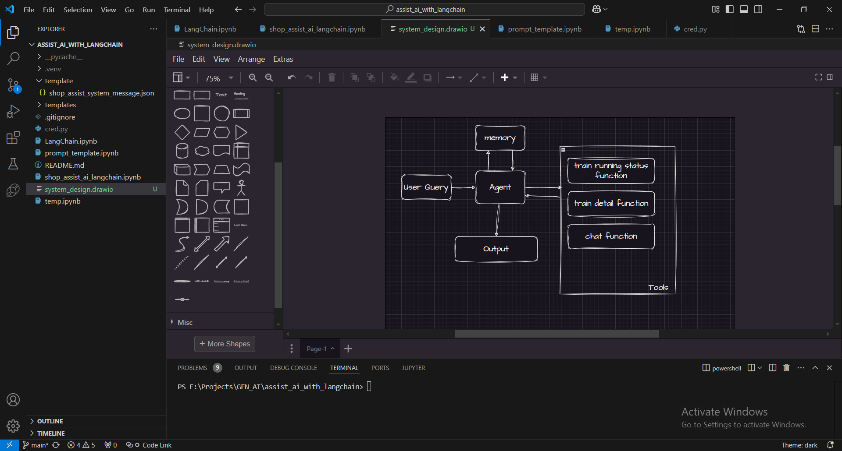

**Implementation :-**

1. Using railways API to fetch real time data
2. Hugging face for llm
3. Agents to enable tools
4. Using langchain because of its capability of creating agents and tool.

**Example Run:-**

Entering new AgentExecutor chain...

Assistant: Thought: Do I need to use a tool? No

AI: Hello! How can I assist you today? If you have any questions or need information about a specific topic, feel free to let me know

Chatbot: Hello! How can I assist you today? If you have any questions or need information about a specific topic, feel free to let me know.

Entering new AgentExecutor chain

Assistant: Thought: Do I need to use a tool? No

AI: Hello! How can I assist you today? If you have any questions or need information about a specific topic, feel free to let me know

Chatbot: Hello! How can I assist you today? If you have any questions or need information about a specific topic, feel free to let me know.

Entering new AgentExecutor chain

Assistant: Thought: Do I need to use a tool? No

AI: Not much, just here to help you out! How can I assist you today?

Chatbot: Not much, just here to help you out! How can I assist you today?

Entering new AgentExecutor chain

Thought: Do I need to use a tool? Yes

Action: trainStatusQuery

Action Input: 22222

Observation: Failed to get data for 22222. Error: You have exceeded the MONTHLY quota for Basic on your current plan, BASIC. Upgrade your plan at <https://rapidapi.com/IRCTCAPI/api/irctc1>

Thought: Do I need to use a tool? No

AI: I'm sorry, Arhat. It seems like there was an issue retrieving the train status for train number 22222. The service I'm using has exceeded its monthly quota. Could you try again later or check the train status through another source? If you need any other assistance, feel free to let me know!

Chatbot: I'm sorry, Arhat. It seems like there was an issue retrieving the train status for train number 22222. The service I'm using has exceeded its monthly quota. Could you try again later or check the train status through another source? If you need any other assistance, feel free to let me know!

Entering new AgentExecutor chain...

AssistantThought: Do I need to use a tool? No

AI: Hello Arhat! I can assist you with a variety of tasks, including but not limited to:

1. **Answering Questions**: Providing information on a wide range of topics.

2. **Writing Assistance**: Helping you draft emails, essays, reports, and more.

3. **Language Translation**: Translating text between different languages.

4. **Summarizing Texts**: Summarizing articles, books, and other lengthy documents.

5. **Learning and Education**: Explaining complex concepts, helping with homework, and offering study tips.

6. **Creative Writing**: Assisting with writing stories, poems, and other creative content.

7. **Programming Help**: Debugging code, explaining programming concepts, and providing coding examples.

8. **General Advice**: Offering advice on a variety of topics, from productivity to personal development.

9. **Entertainment**: Telling jokes, sharing interesting facts, and engaging in conversation.

If you have a specific task or question in mind, feel free to let me know![0m

Finished chain.

Chatbot: Hello Arhat! I can assist you with a variety of tasks, including but not limited to:

1. **Answering Questions**: Providing information on a wide range of topics.

2. **Writing Assistance**: Helping you draft emails, essays, reports, and more.

3. **Language Translation**: Translating text between different languages.

4. **Summarizing Texts**: Summarizing articles, books, and other lengthy documents.

5. **Learning and Education**: Explaining complex concepts, helping with homework, and offering study tips.

6. **Creative Writing**: Assisting with writing stories, poems, and other creative content.

7. **Programming Help**: Debugging code, explaining programming concepts, and providing coding examples.

8. **General Advice**: Offering advice on a variety of topics, from productivity to personal development.

9. **Entertainment**: Telling jokes, sharing interesting facts, and engaging in conversation.

If you have a specific task or question in mind, feel free to let me know!

Entering new AgentExecutor chain...

AI: Great to hear that! How can I assist you further today?[0m

Finished chain.

Chatbot: Great to hear that! How can I assist you further today?

Entering new AgentExecutor chain...

AI: Your name is Arhat. Is there anything specific you would like to know or discuss?[0m

Finished chain.

Chatbot: Your name is Arhat. Is there anything specific you would like to know or discuss?

Entering new AgentExecutor chain...[0m

AI: You're welcome, Arhat! If you need anything in the future, feel free to reach out. Have a great day!

Finished chain.

Chatbot: You're welcome, Arhat! If you need anything in the future, feel free to reach out. Have a great day!

Chatbot: Goodbye!

**Challenges :-**

1. Its been challenge for implementing at very first go.
2. Its been a challenge to decide to use langchain or lamaindex